Genesee Valley Citizens for peace
41st ANNual Vigil

For People & the Planet:

Commemorating the 70th Anniversary of the Atomic Bombings of Hiroshima & Nagasaki

WEDNESDAY,
August 5, 2015, 7:30 p.m.
Peace Vigil at Avon Traffic Circle
Routes 5 & 20 Avon, NY
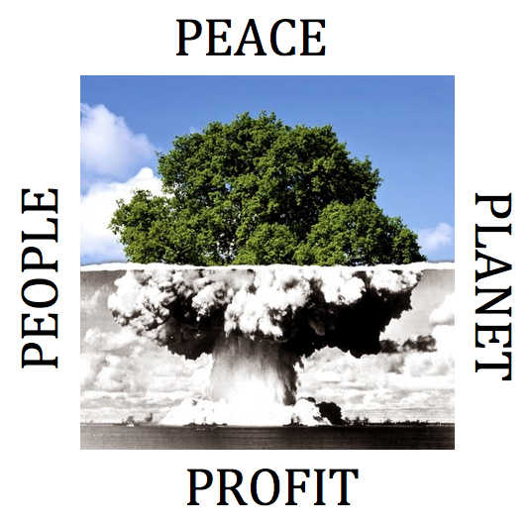

Contact: Hank Stone, 585-624-3673 <hstone@rochester.rr.com>

