The Rochester Committee on Latin America invites you to
The upstate premier of
Resistencia: The Fight for the Aguan Valley
On June 28th 2009, the first coup d'état in a generation in Central America overthrew the elected president of Honduras. A nationwide resistance movement was born, which took inspiration from the daring act of the farmers of the Aguan Valley to take over 10,000 acres of palm oil plantations claimed by the country's largest landowner. Filmed over four years beginning with the coup itself, 'Resistencia: The Fight for the Aguan Valley' follows three key members of the farmers' resistance as they convert the plantations into a workers’ co-op and agitate for a more democratic state.

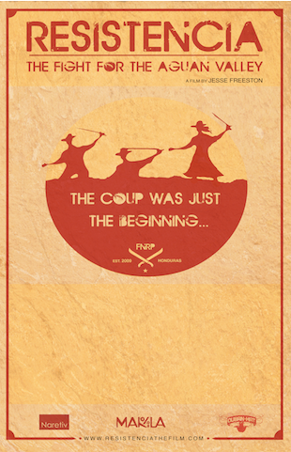
Wednesday, October 7, 2015, 6:30 PM

Little Theatre, Rochester NY

Filmmaker Jesse Freeston will be with us to lead a post-film discussion!
Free and open to the public.

“The tears and the eloquence of the people affected must be watched. I cannot tell them to you.”—David Swanson, Counterpunch

