172KShare 507Tweet 409Share 66Reddit 257Share 267Email

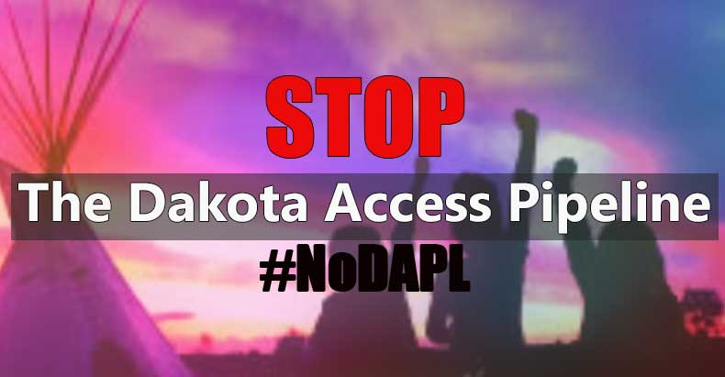image: http://thefreethoughtproject.com/wp-content/uploads/2016/09/dapl.jpg

Cannon Ball, ND – While many Americans passively support the Standing Rock Sioux’s fight to stop the construction of the Dakota Access Pipeline, aside from showing up in Cannon Ball, North Dakota (which many simply can’t do) – to actively participate in the protests – most people are unsure of what they can actually do to support the Sioux at Standing Rock aside from posting on social media.
Here is a list of ten things that people can do to show their support. Some methods may be more effective than others, but the key is utilizing multiple avenues of resistance in an effort to provide full spectrum resistance against the construction of the Dakota Access Pipeline.

1. Call North Dakota governor Jack Dalrymple at 701-328-2200. When leaving a message stating your thoughts about this subject please be professional.

2. Sign the petition to the White House to Stop DAPL: https://petitions.whitehouse.gov/…/stop-construction…

3. Donate to support the Standing Rock Sioux at http://standingrock.org/…/standing-rock-sioux-tribe…/

4. Donate items from the Sacred Stone Camp Supply List: http://sacredstonecamp.org/supply-list/

5. Call the White House at (202) 456-1111 or (202) 456-1414. Tell President Obama to rescind the Army Corps of Engineers’ Permit for the Dakota Access Pipeline.

6. Contribute to the Sacred Stone Camp Legal Defense Fund: https://fundrazr.com/d19fAf

7. Contribute to the Sacred Stone Camp gofundme account: https://www.gofundme.com/sacredstonecamp

8. Call the Army Corps of Engineers and demand that they reverse the permit: (202) 761-5903

9. Sign other petitions asking President Obama to stop the Dakota Access Pipeline. Here’s the latest to cross my desk – https://act.credoaction.com/sign/NoDAPL

10. Call the executives of the companies that are building the pipeline:

a. Lee Hanse Executive Vice President Energy Transfer Partners, L.P. 800 E Sonterra Blvd #400 San Antonio, Texas 78258 Telephone: (210) 403-6455 Lee.Hanse@energytransfer.com

b. Glenn Emery Vice President Energy Transfer Partners, L.P. 800 E Sonterra Blvd #400 San Antonio, Texas 78258 Telephone: (210) 403-6762 Glenn.Emery@energytransfer.com

c. Michael (Cliff) Waters Lead Analyst Energy Transfer Partners, L.P. 1300 Main St. Houston, Texas 77002 Telephone: (713) 989-2404 Michael.Waters@energytransfer.com
The most effective means of showing support for this cause is to actively participate in protecting this sacred land. Anyone who is able to travel to the peaceful encampments is encouraged to do so. For those unable to make the journey to North Dakota, please utilize the alternate methods provided to show your support for the Standing Rock Sioux who have united over 100 tribes from across the U.S. Please join this effort to stop this pipeline, which desecrates sacred lands and has serious potential to damage or destroy the Standing Rock reservations lifeblood – its water.

Be the change you wish to see in this world. — Mahatma Gandhi
172KShare 507Tweet 409Share 66Reddit 257Share 267Email
Read more at http://thefreethoughtproject.com/10-protest-dakota-access-pipeline/#fUDwUf76PwSOauyH.99

