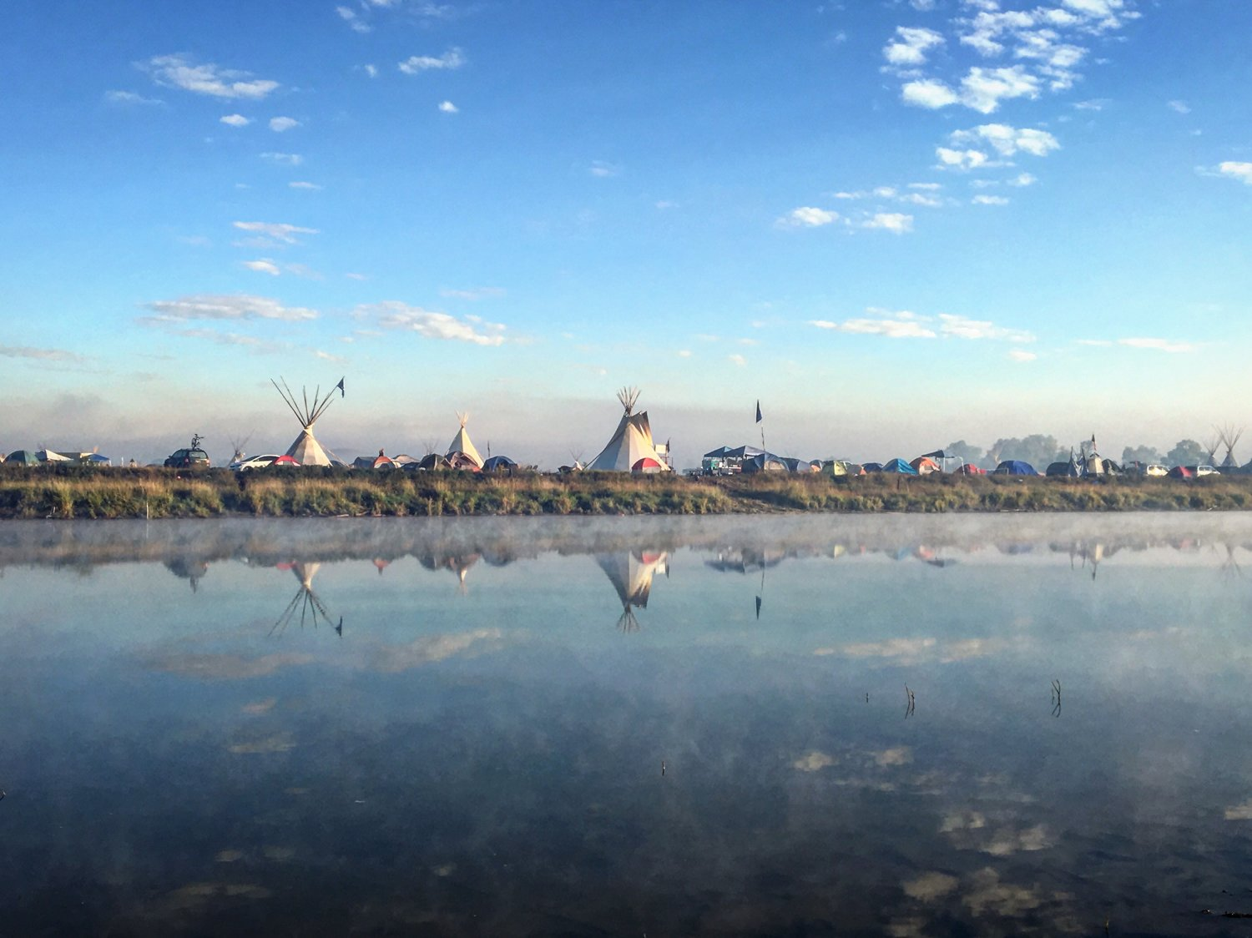

**Needed Supplies**

**(For more info, check our** [**FAQ**](http://www.sacredstonecamp.org/faq/#howtohelp)**)**

**Supplies, cash, or check donations can be sent to:**

**Sacred Stone Camp P.O. Box 1011, Fort Yates, ND 58538**

or

**202 Main Street Fort Yates, ND 58538**

**We also have an** [**Amazon Wish List**](http://www.amazon.com/registry/wishlist/196PVIWRDX1M4)**.**

**\*\*\*\*IF YOU SEND MAIL/PACKAGES TO INDIVIDUALS TO OUR ADDRESSES: Please include a contact email or phone number on the package/letter so we can find the individual. If you can't include it on the mail itself please send a text to (701) 301-2238 saying if it's a letter or a package, who it is addressed to, and how to contact that person so we can get it to them. Also make sure the person you are sending it to is at Sacred Stone Camp, not Oceti Sakowin, Red Warrior, Rosebud, or the other camps. We only accept mail for Sacred Stone Camp. If you don't know, please ask the person you are sending to. Thanks for making it easier for us to get the mail you send to its owner.**

**>>At this time we have a surplus of clothes and encourage you to buy things from our Amazon list instead of sending old clothes.**

**>>>Please be aware that we only have limited solar and wind power at the camps.**

**TOP NEEDS**

* **FIREWOOD (PREFERABLY OAK, MAPLE, ASH)**
* **Tipis/Tipi Poles/TIpi liners for winter**
* **Pick-Up Truck w/ 4 wheel Drive**
* **Trailers/Campers (for winter shelters)**
* **snow tires - Various sizes; Tire Chains**
* **GAS CARDS**
* **wall Tents with woodstoves and poles**
* **sleeping bags for subzero temperatures (inc. military style)**

**FULL SUPPLY LIST**

* **Banners, sheets (we love it when you make banners and send them to us!)**
* **BATTERY PACKS FOR CHARGING PHONES**
* **canvas - heavy duty only please**
* **car ports**
* **carts and wheelbarrows for hauling wood**
* **Cigarettes-Marlboro reds and camels**
* **come alongs**
* **FIREWOOD (Preferably oak, maple, ash) <<< This is one of our biggest winter needs**
* **fire extinguishers**
* **propane**
* **fur blankets**
* **tesoro Gas Cards**
* **gas generators**
* **Gift cards - Amazon, Verizon, GAS**
* **insulated carhartt type coveralls, overalls, coats**
* **Lighters**
* **Material for tobacco ties (All Colors)**
* **MONEy**
* **PAINT (INC. SPRAY PAINT)**
* **Pick up Trucks (in good condition to handle winter)**
* **Power inverter**
* **propane heaters (small)**
* **Ropes, Tie Downs**
* **Shipping Container 20 Ft**
* **SLEEPING BAGS (FOR -10 DEGREES F AND LOWER - PLEASE NO WARM WEATHER BAGS AT THIS TIME)**
* **snowmobiles**
* **snow tires (inquire for sizes)**
* **Solar chargers for electronic devices**
* **Solar panels, inverter**
* **storage bins - heavy duty - all sizes**
* **Tarps - Heavy Duty only**
* **tire chains**
* **Tents (that can stand up to high winds, snow, subzero temps)**
* **thermal bed rolls**
* **Tipis and Tipi poles**
* **tipi liners for winter**
* **tow straps**
* **Walkie talkies with long range, CB radios**
* **Water buffalo (tank)**
* **water tank with heater**
* **winter salt for roads**
* **wood stoves (mostly small ones for tipis)**
* **YOUNG WARRIORS!!**