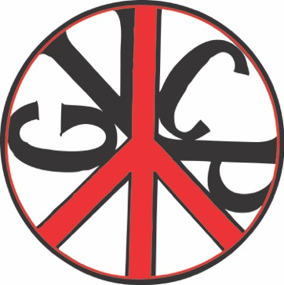

**Genesee Valley Citizens for Peace**

is celebrating its

**45th** **anniversary**

of working actively for a world of peace, justice, and freedom.

Please celebrate with us by joining us for the

**International Day of Peace**

**Thursday, September 21, 4:00 pm**

**St. Michael’s Episcopal Church, 23 Main St., Geneseo**

Please join us for this **family-friendly event**, which will include music, collaborative games, and a keynote speech by

**Kevin Martin**, President of Peace Action.

We will present GVCP’s Genesee Valley Peacemaker Award to

**Kate Alexander**, Director of Policy and Outreach for

Peace Action New York State

At 5:45 pm, we will walk to the SUNY Geneseo campus, where we will join our sister group, **Geneseo Peace Action**, and participate

in their International Day of Peace event.

**Bring your family, your friends, and your neighbors!**

**Geneseo Valley Citizens for Peace**

PO Box 363, Geneseo NY, 14454 <[www.gvcp.org](http://www.gvcp.org)> Facebook

**GVCP founded in 1972: “Human Race Not Arms Race”**

*Free Pizza & Cookies for Everyone*

Macintosh HD:Users:terayarowsky:Desktop:dove.pdf