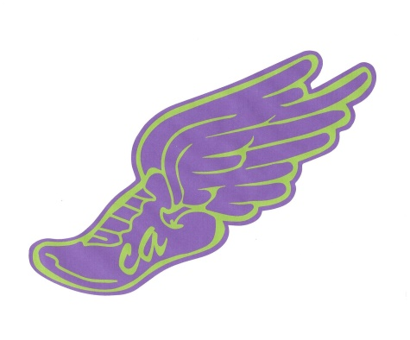 ”14 for Claire” Quest
In honor of Claire Allen I began a “Quest” to run 14 5Ks in her memory over the course of the next 11 months. The goal is to have people “sponsor” the quest by donating to two charities that were important to Claire and to her family. Many people have shown an interest in joining with me to complete some or all of the runs this year and her parents have chosen to call us “Claire’s Crew.”
Claire’s parents have given their approval and fully support this effort. They suggested that donations towards this effort be made to either The Malala Fund or The Rochester Area Literacy Council. There is also a Face Book page that I created that you can “follow” to see the progress. It is titled “14 for Claire.”
I have received wonderful feedback from so many in regards to this effort and have already raised over $650 in her memory that has been donated to these two wonderful charities. All race fees are covered by the runners, so all donations go directly to the charities. Two races have already been completed!
In addition, The Allen’s approved the sale of a few items to help raise additional monies that can be worn or displayed by those who want to remember Claire and show support for this cause. ALL proceeds will go to the charities.
I am sharing this with you in the hopes that you may want to participate in some of the runs, support the cause by donating or that you may want an item to show your support. Below I have listed the two charities and how to donate to each of them and I have attached pictures of the products along with the order form. The first shipment of hats and bumper stickers are due in by Thanksgiving. The tee shirts will be ordered once I have 24 orders and can place the first order. We already have 1/3 of the orders we need.
Please let me know if you have any questions and of course, there is no obligation to join the quest or purchase anything.
Thank-you for your time,
Jenn Mehlenbacher camkysmom@yahoo.com

The Charities:

The Malala Fund: A direct donation may be made to: https://www.classy.org/team/142227
The Rochester Area Literacy Council: Please make payment directly to them at: The RALC PO Box 92333 Rochester, NY 14692 Memo Line: 14 for Claire

Products:
The next pages so close ups of the products followed by the order form

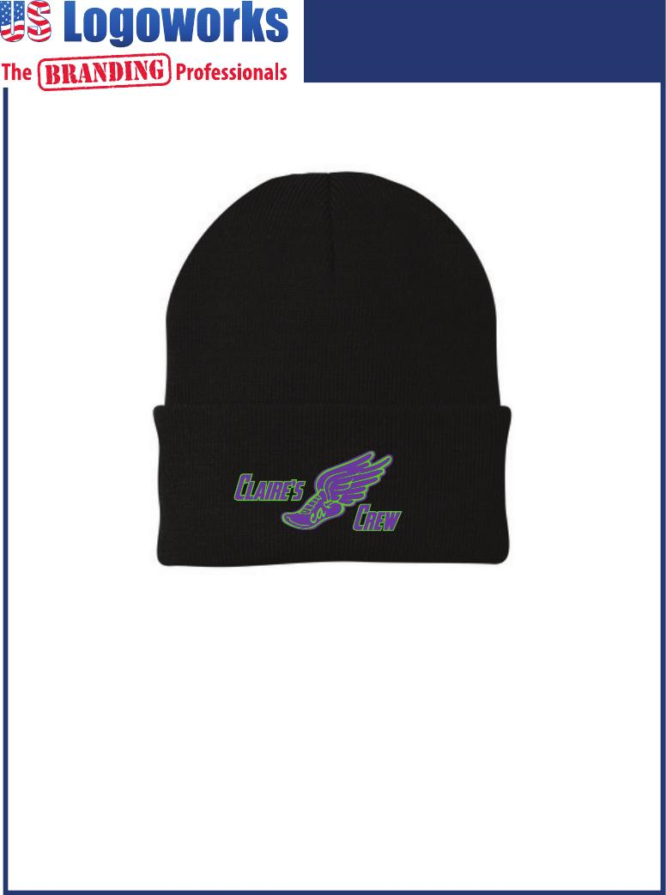
Knit Cap- $10 Rolled Knit Ski Cap-Embroidered

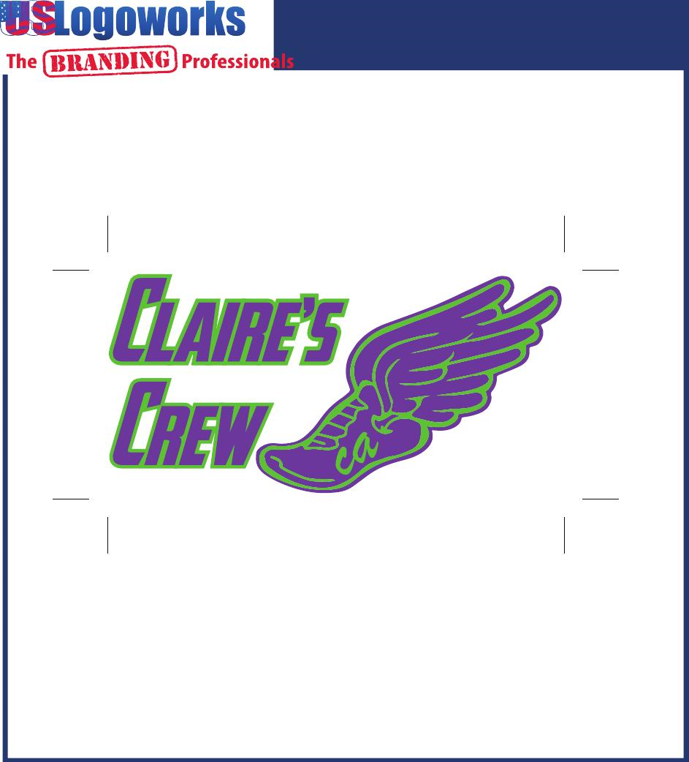
Bumper Sticker- $5 6 1/4” x 3 1/8” Vinyl Bumper Sticker

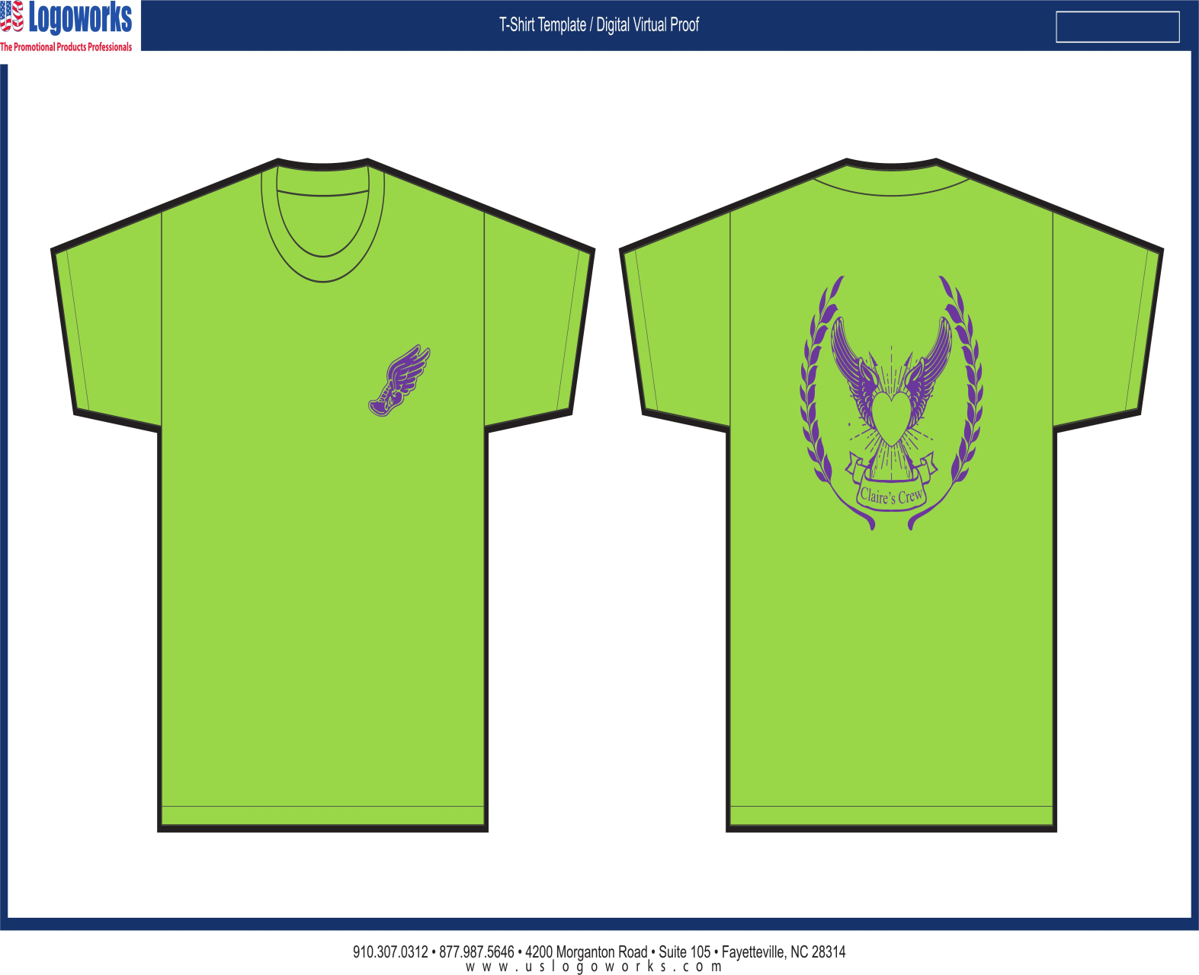
Short and Long Sleeve Tees: $12 (short) and $15 (long) Sizes: adult small - 3XL Hanes, 100% Ring Spun

Order Form:

Name: ________________________ Phone Number: __________________
Address: ______________________ E-Mail: _________________________
______________________

Item(s): Quantity: Size (adult S-3x): Total Each:
Bumper Stickers: ________ x $5.00 each _____________
Knit Hat: _________ x $10.00 each _____________
Short Sleeve Shirt: _________ x $12.00 each __________ ______________
Long Sleeve Shirt: _________ x $15.00 each __________ ______________
Total for all: ______________

Contact/Remit Payment To:
Jenn Mehlenbacher 15 Ivy Lane Geneseo NY 14454 585-315-2380 camkysmom@yahoo.com
THANK YOU!
A friend is providing these to me “at cost.” All proceeds from the sale of these items will be split evenly between The Malala Fund and The Rochester Literacy Council.

